**DNA Fans**

**Manual**

**Introduction**

DNA Fans is an application written in vb.net for basic DNA sequence manipulations, such as reverse complement, translation, restriction sites and alignment. It runs in Windows system, Win 7 or later versions. A .net frame work is needed if running in Win XP. The Orientation of DNA Fans is small, simple, convenient and smart. Most of the functions can be used without reading this manual. Just download and unzip the DNAFans.zip file and put the folder anywhere you like. No installation is needed.

**What can DNA Fans do?**

Complement

Reverse complement

Upper case/Lower case conversion

DeGap

Translation

Restriction sites

Compare

GC content

Protein molecular weight

**DeGap**

The DeGap function is to remove characters such as numbers, space, new lines and special characters (~!@#$%^*) and keep only letters. For example, a sequence download from GenBank is like Fig. 1. Simply paste the sequence into the upper text box and click DeGap button.

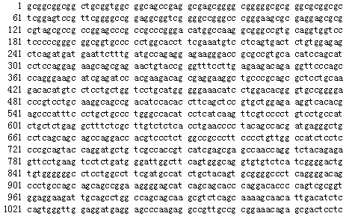

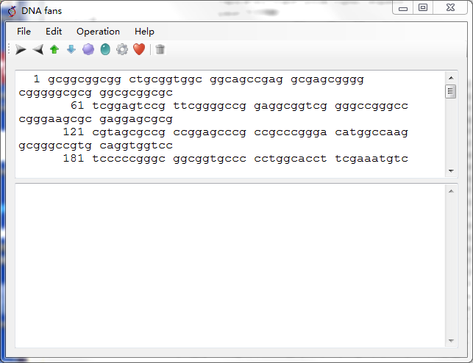

Fig. 1

The sequence will change to what is showed in Fig. 2 (DeGap only happens in the upper text box).

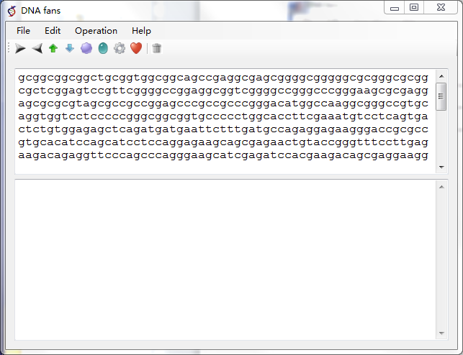

Fig. 2

**Compare**

The Compare function is to compare two nucleic acid or protein sequences. It uses the “align two seq” function of NCBI BLAST. Therefore you need to have BLAST+ installed in your Win system before using this function. Simply paste the two sequences you want to compare into the two text boxes and click the Compare button, then the alignment result will pop out.